**Experiment No. 8**

**Aim:** To implement Image smoothing/ Image sharpening using low pass and high pass filter

**Objective:**

1) Apply Low pass filter to get image smoothening

2) Apply High pass filter to get image sharpening

**Input Specifications:**

Colour Image of size MXN

**Theory:**

**Image Smoothening ( Low Pass Filering)**

A low pass filter is the basis for most smoothing methods. An image is smoothed by decreasing the disparity between pixel values by averaging nearby pixels

Using a low pass filter tends to retain the low frequency information within an image while reducing the high frequency information. An example is an array of ones divided by the number of elements within the kernel, such as the following 3 by 3 kernel:



**Image Sharpening (High Pass Filering)**

A high pass filter is the basis for most sharpening methods. An image is sharpened when contrast is enhanced between adjoining areas with little variation in brightness or darkness

A high pass filter tends to retain the high frequency information within an image while reducing the low frequency information. The kernel of the high pass filter is designed to increase the brightness of the center pixel relative to neighboring pixels. The kernel array usually contains a single positive value at its center, which is completely surrounded by negative values. The following array is an example of a 3 by 3 kernel for a high pass filter:



**Problem Definition:**

1. Take a color image of size MxN
2. Convert color image to Gray Scale Image
3. Perform convolution of image with low pass filter mask
4. Perform convolution of image with high pass filter mask
5. Conclude by specifying the applications where LPF and HPF can be used

**CODE:**

| clc; Iimg=imread('cameraman.tif'); subplot(2,2,1) imshow(Iimg); title('Original image'); Iimg = imnoise(Iimg,'gaussian',0,0.025); subplot(2,2,2) imshow(Iimg); title('Blurred image'); filtered = filter2(fspecial('average',3),Iimg)/255; subplot(2,2,3) imshow(filtered); title('Filtered Image'); original_image=imread('cameraman.tif'); kernel = 1/6*-1*ones(3); kernel(2,2) = 1/6*8; enhancedImage = imfilter(original_image, kernel); subplot(2,2,4) imshow(enhancedImage); title('Edge Enhanced image'); |
| --- |

**OUTPUT:**

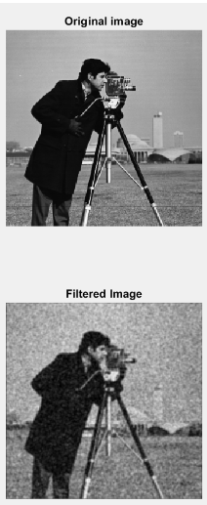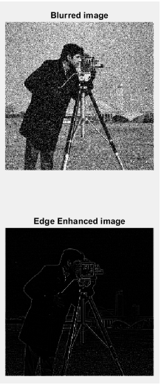

**CONCLUSION:**

In this experiment, we leant how to add noise to images using MATLAB, how to filter noise from images using a 3*3 mask and how to do edge detection using high pass filter in MATLAB.

**Name:** Junaid Altaf Girkar

**SAP ID:** 60004190057

**Division:** BE Comps A2